
Name: Abdul Samad
Program: BSSE Group A
Semester: 5th
Date: September 17, 2026
*-----------------------------------------------*

Lab Task 2.1
Program Output:

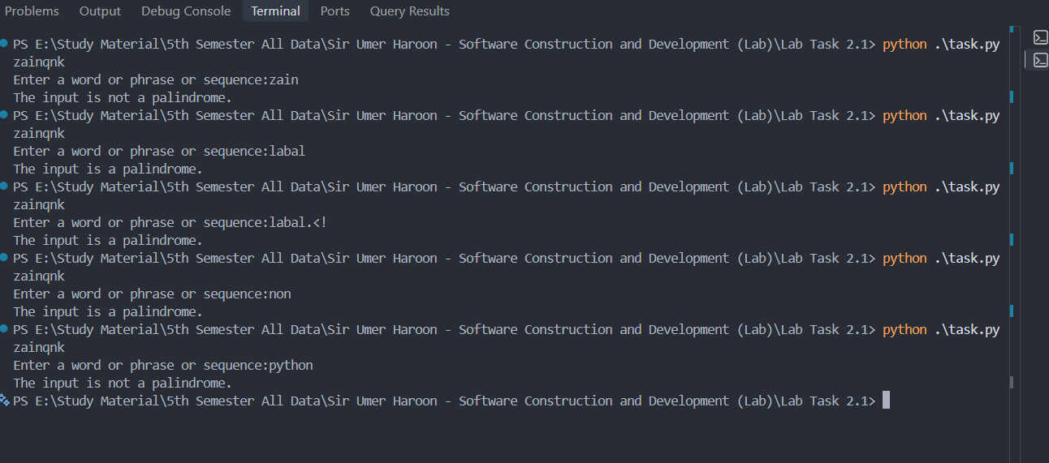
*-----------------------------------------------*

The End

